|  |  |  |  |
| --- | --- | --- | --- |
|  | Bansilal Ramnath Agarwal Charitable Trust's  Vishwakarma Institute of Information Technology  Department of  Artificial Intelligence and Data Science | | |
| Name: Siddhesh Dilip Khairnar | | | |
| Class: SY-B tech | Division: B | | Roll No: 272028 |
| Semester: 3rd | | Academic Year:2022-2023 | |
| Subject Name & Code: ADUA21206 - Data Visualization | | | |
| Title of Assignment: Visualization in Tableau | | | |
| Date of Performance: 14/10/2022 | | Date of Submission: 24/10/2022 | |

Aim: Visualization in Tableau

Problem Statement: Download data set from Kaggle/Tableau/data world. Create visualizations, stating the questions addressed for each visualization.

1. Bar chart & Line Chart
2. Scatter plot & pie chart
3. Sparkline/Text table/Maps
4. Stacked area chart & Gantt chart
5. Highlight table & heat map

Theory/Writeup:

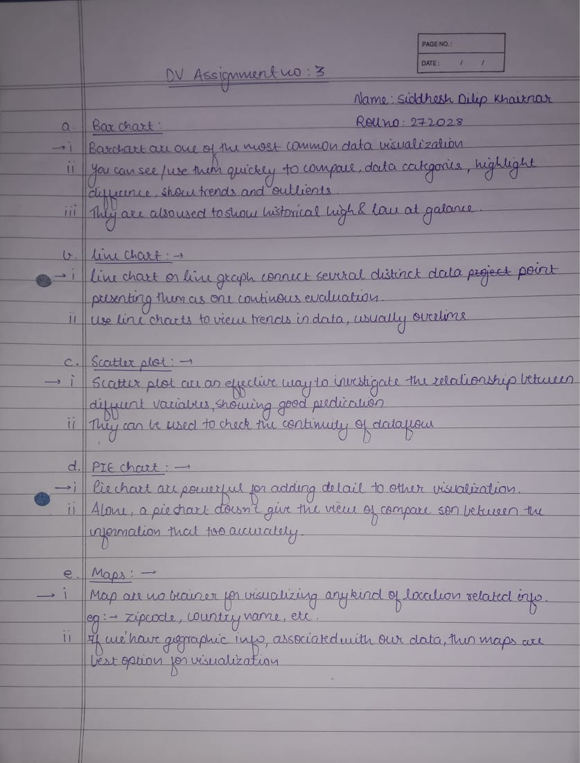

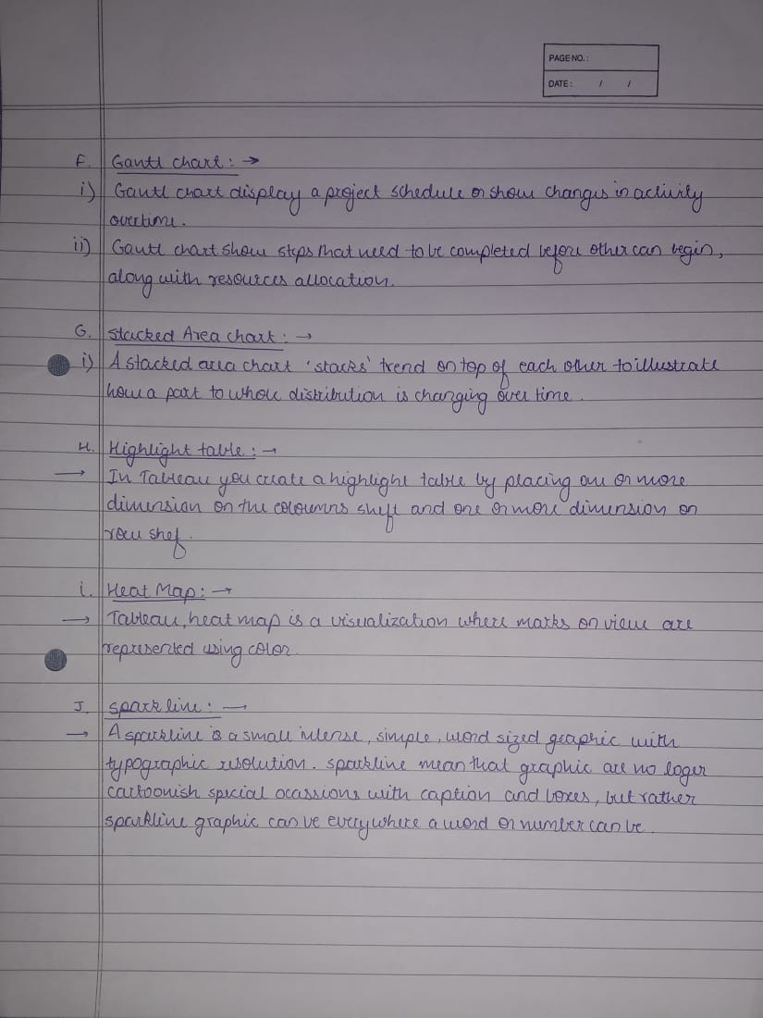

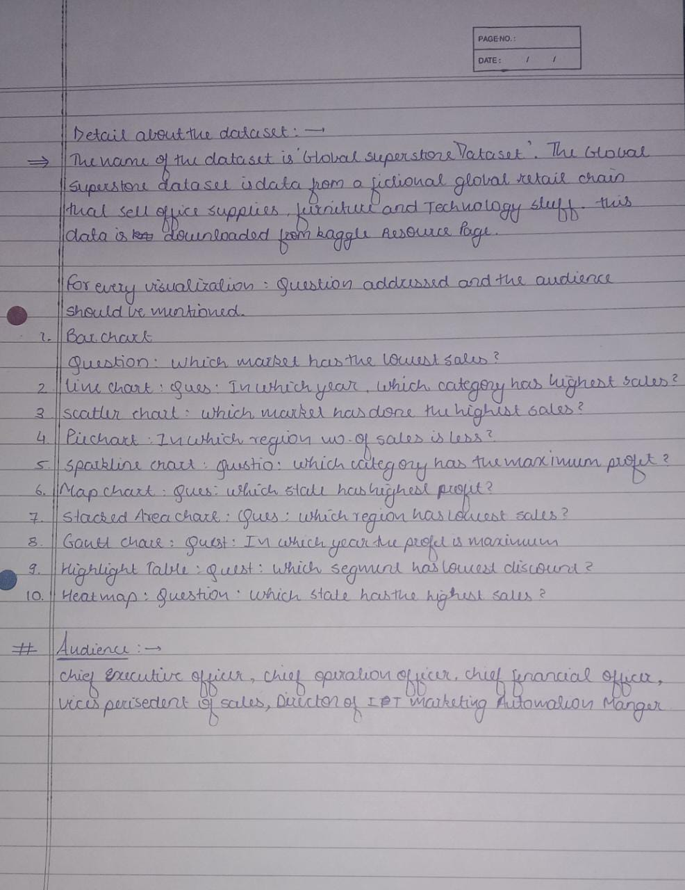

BAR CHART: 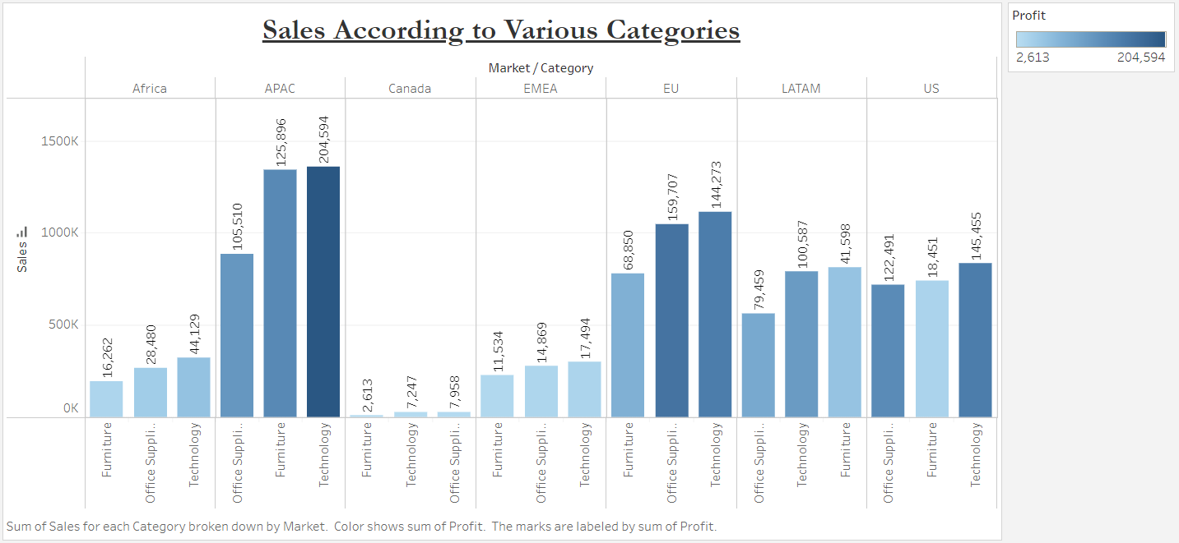

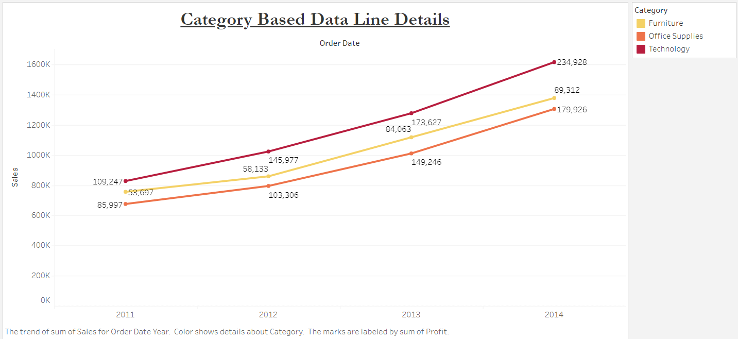LINE CHART:

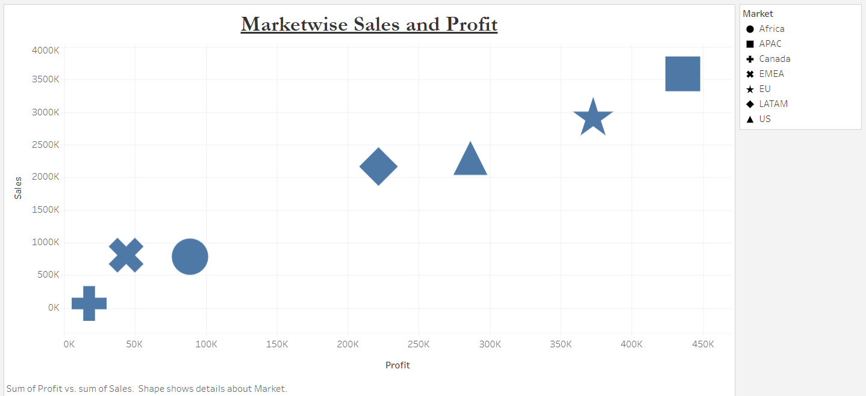SCATTER CHART:

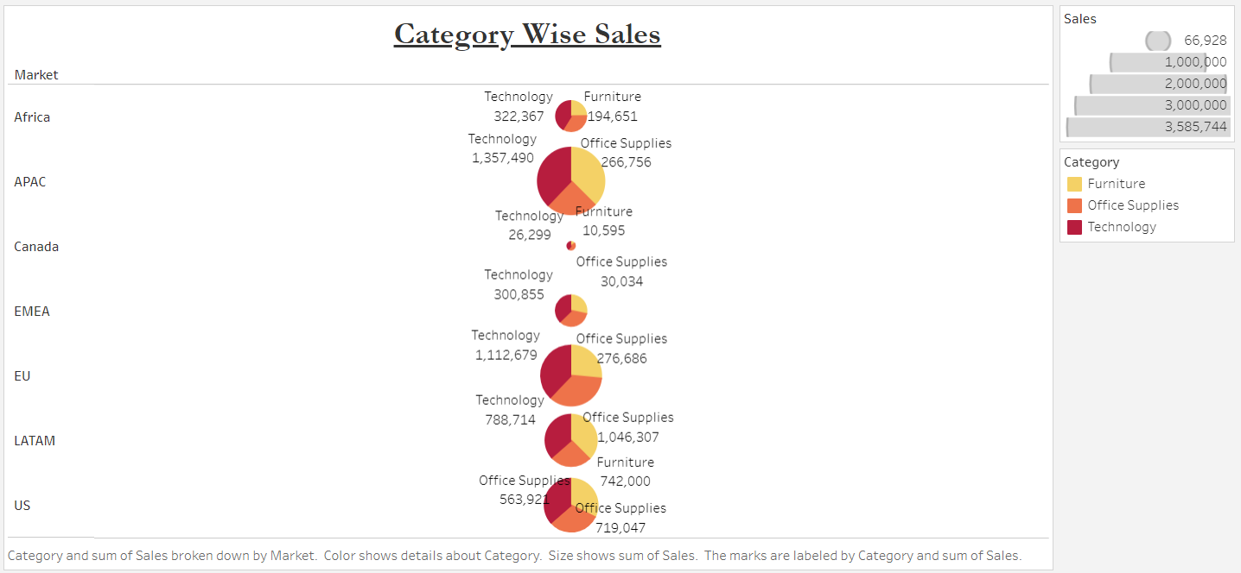PIE CHART:

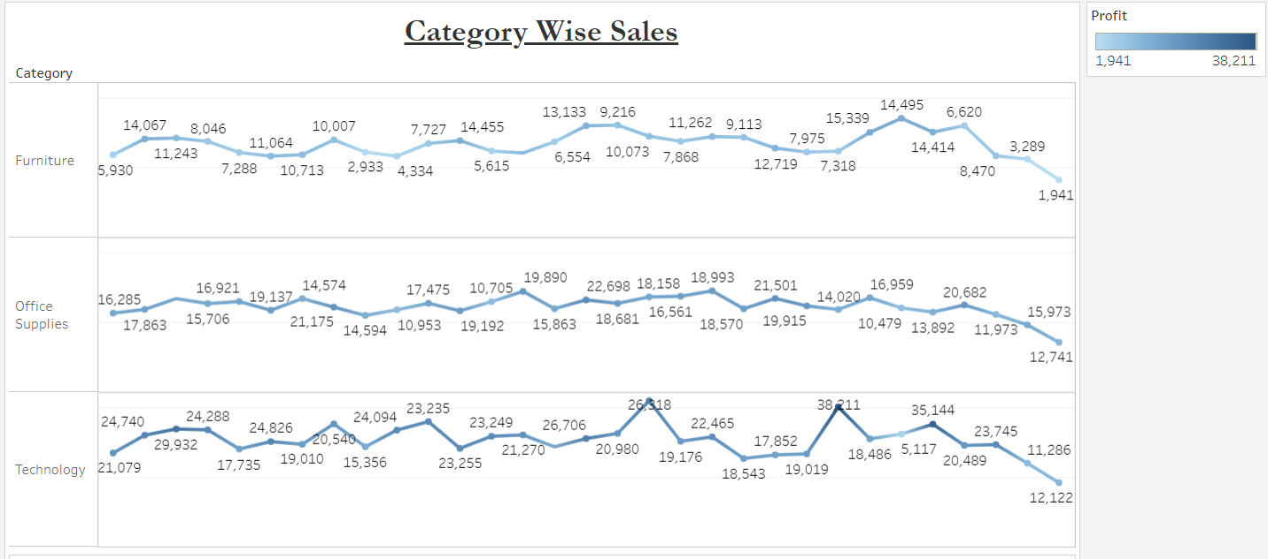SPARKLINE CHART:

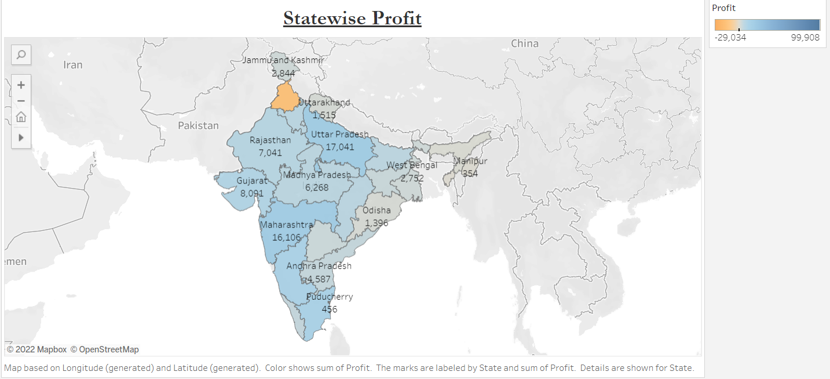MAP CHART:

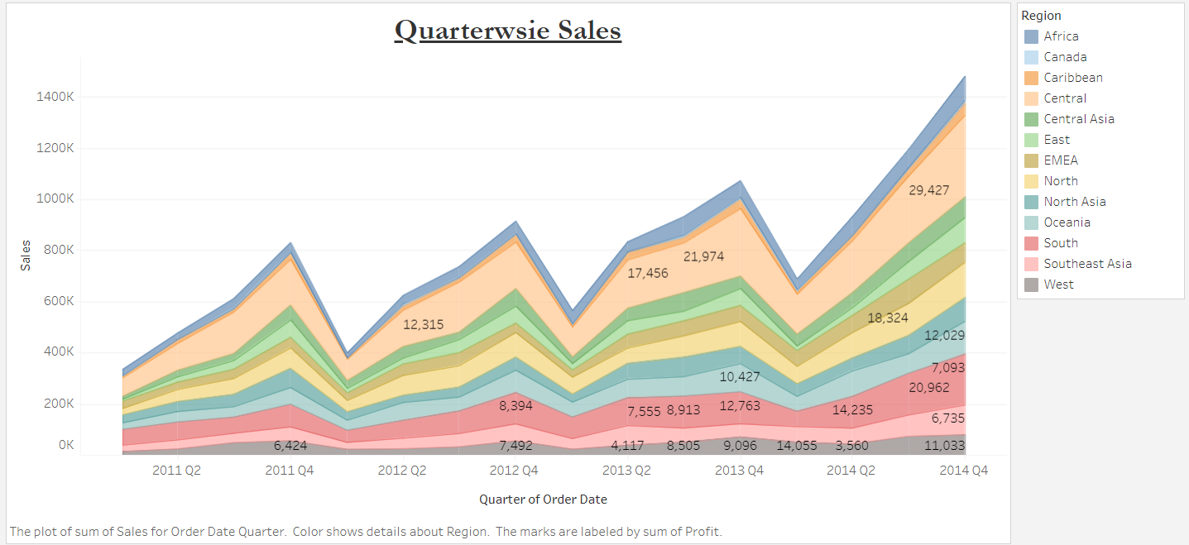STACKED AREA CHART:

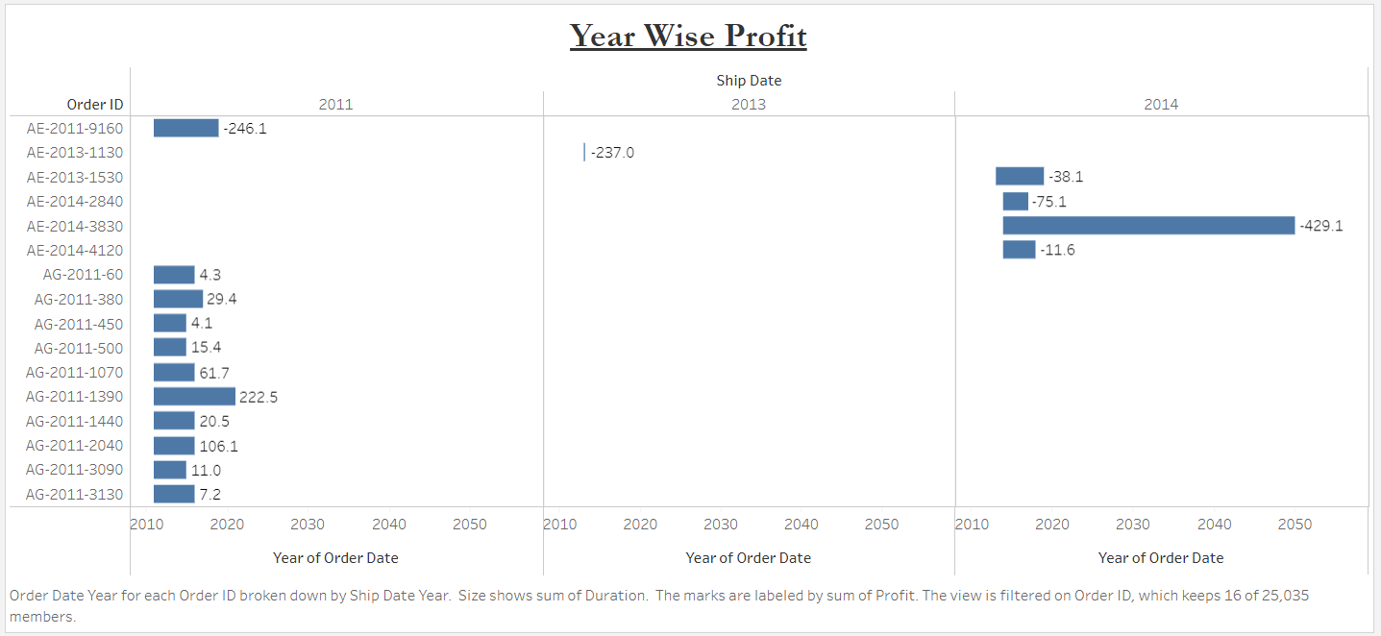GANTT CHART:

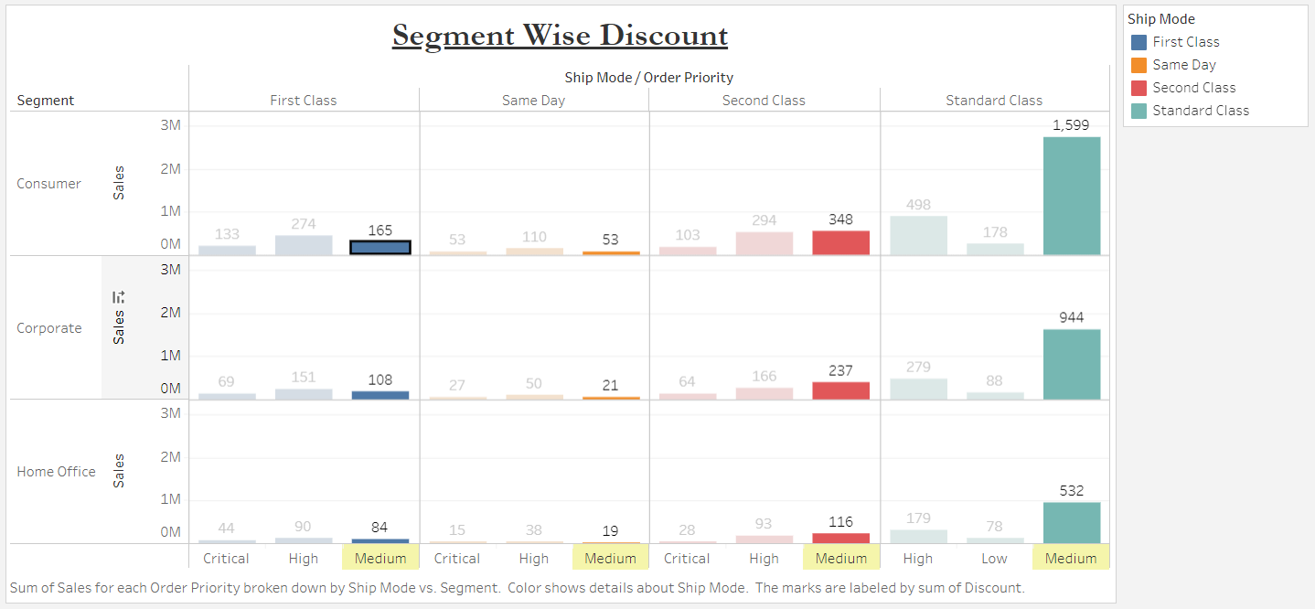HIGHLIGHT TABLE:

Dataset:

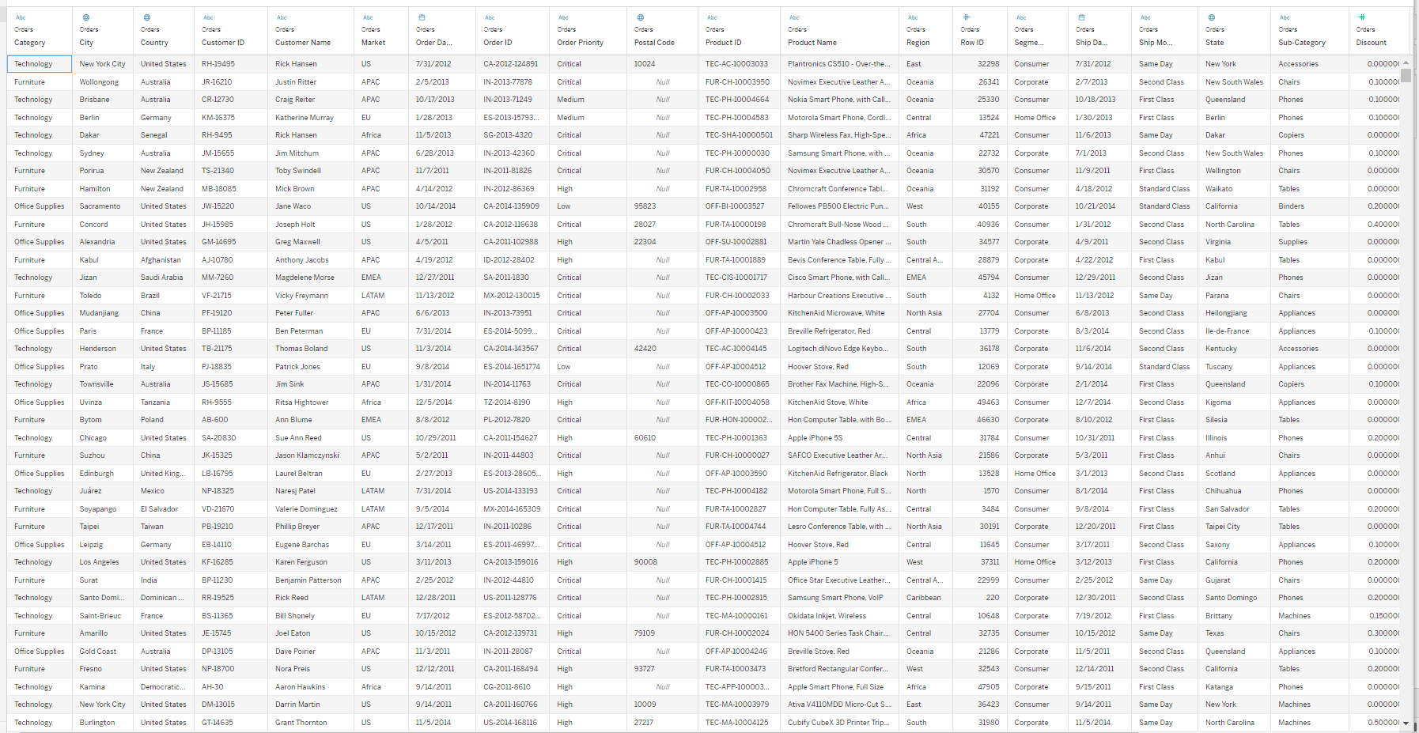

Conclusion: Through this assignment, I had learned how to make different types of visualizations and how to do it analysis.

Tableau Public Profile Link:

<https://public.tableau.com/app/profile/siddhesh.dilip.khairnar/viz/B_28_SiddheshKhairnar_ASS_3/PIECHART>